# QUESTION 1

You are given a task a lecturer at your college to write a complete program which will allow the user to calculate Cylinder Volume

The area formula is:

*Cylinder Volume= (pi*Radius*Radius)*Height*

*The value of pi=22/7*

**BELOW IS THE GRAPHIC USER INTERFACE (GUI) DIAGRAM**

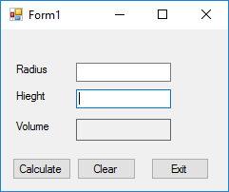

**BELOW IS THE UNIFIED MODELLING LANGUAGE (UML) DIAGRAM**

Cylinder Volume

-Radius

-Hieght

+Volume()